PROJECT NAME. READY FOR EXPORT.
ALOKA TREVOR.
PROJECT DESCRIPTION.
Ready for export is from a body of work that speaks to the movement of the African body as a material and tool. The work juxtaposes precious metals and the African body to speak to the position of the African in various places they occupy. From the brain drain carrying away seasoned professionals to the mass migration of Laborers the African is in a way primed and ready for export or for export only. Narrowing it down to my immediate context, a lot of Ugandans did line up at the ministry of internal affairs in Kampala in large numbers every day before covid to apply for a passport so that they can leave the country in search of greener pastures and I am certain there is greater chance that this will be the case again as soon as things get back to normal. Being an Artist, an advocate and enthusiast of talent, I imagine all these people each being so good at something, their professions, previous professions and their God given talents, and now all this talent and professionalism won`t be used at all but rather be benefited from by another country where these people go, or even put to a waste by not being used.
I intend to do paintings of faces with skin complexions of GOLD/COPPER colors given the juxtaposition of precious metals I mentioned about in the first paragraph, basically I imagine these figures painted in golden and copper skin forms or torn measuring them to the worth they have or could claim if worked upon .I intend to paint everyday faces of people I know with everyday passions of things and talents ,mostly children and youths because I believe a revolution is more impactful and achievable when believed in by the next generation. I plan on doing these paintings on objects that will symbolize particular talents/professions. Objects like race motor bike helmets, boxing punching gloves, sewing machines, soccer balls and any other that I might think of .Furthermore, I plan on creating installation pieces of treasure and wooden cargo boxes along other objects like jute sacks, usual paper boxes and package containers representing different professions and talents maybe being packed in them, these will be exhibited in a warehouse setting assuming these talents and professions are in a clearance area waiting to be exported. Also I will have markings on them [stamps] saying ready for export on each of these packaging objects being exhibited. I also plan on making wooden blocks with the size of golden bars that I will later spray on with gold colored spray paint to turn them into gold bars then have them arranged in my exhibition space into the size and shape of pedal stools, and my symbolic objects [race motor bike helmets etc.] will be placed on each of them pedal stools.
In a conversation with “ Aloka Joshua” my young brother who loves football a lot, he says he will play for Arsenal someday as its team captain, why not “Vipers or police FC or even Uganda Cranes?” I asked curiously. Many young African professionals / talents / creatives call them anything, truth be told, me inclusively, strive for the western market as a breakthrough and the only worthy arena for triumphers in various sectors thus degrading our own local African platforms. An African musician is not looked at as iconic and great regardless of all the big hits and messages put across through their songs not until they get nominated in Western celebrations like the Grammys, question to myself and my audience is, why should this be the case ,why should the outside world measure or determine the magnitude of Africans?.
This kicks off from a really broad point of pan Africanism but should also be looked at from its simplest and smallest form also, may be if we start celebrating our own and elevating them, things could change for the better and we’d have a valued say on our own affairs as Africans .Lastly we’ve always thought that the continent was or is only being exploited of only natural minerals yet it’s also being drained of professionals and talents.
The points of focus in this project are intended to be execution and technique.
I plan on using oil paint to paint the faces for this entire body of work of ten painted symbolic objects and 10 wooden cargo boxes, 15 usual card paper boxes, 98 jute sacks and 20 cargo containers for the installation pieces. I will also have to make 213 wooden blocks for the gold. Lastly I plan on commissioning a carpenter in my home area to make the cargo boxes and the golden bars

Below are a few sketches of my vision.
Thank you.

I hope to have cargo boxes arranged throughout the warehouse setting.
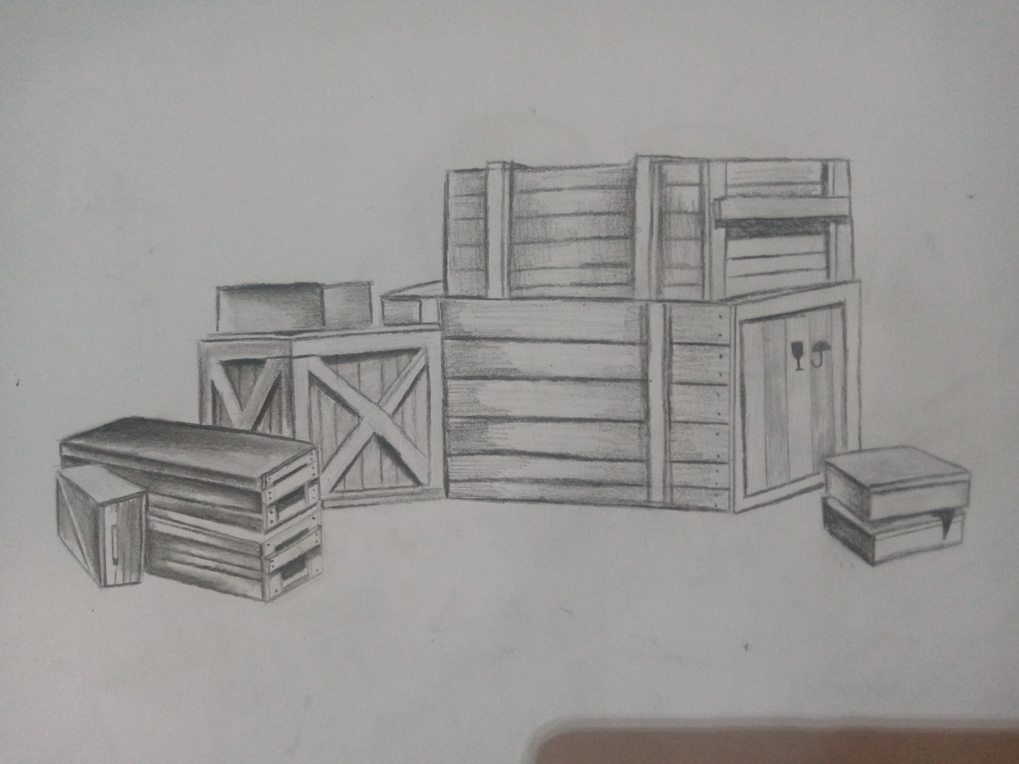

A sketch of cargo boxes
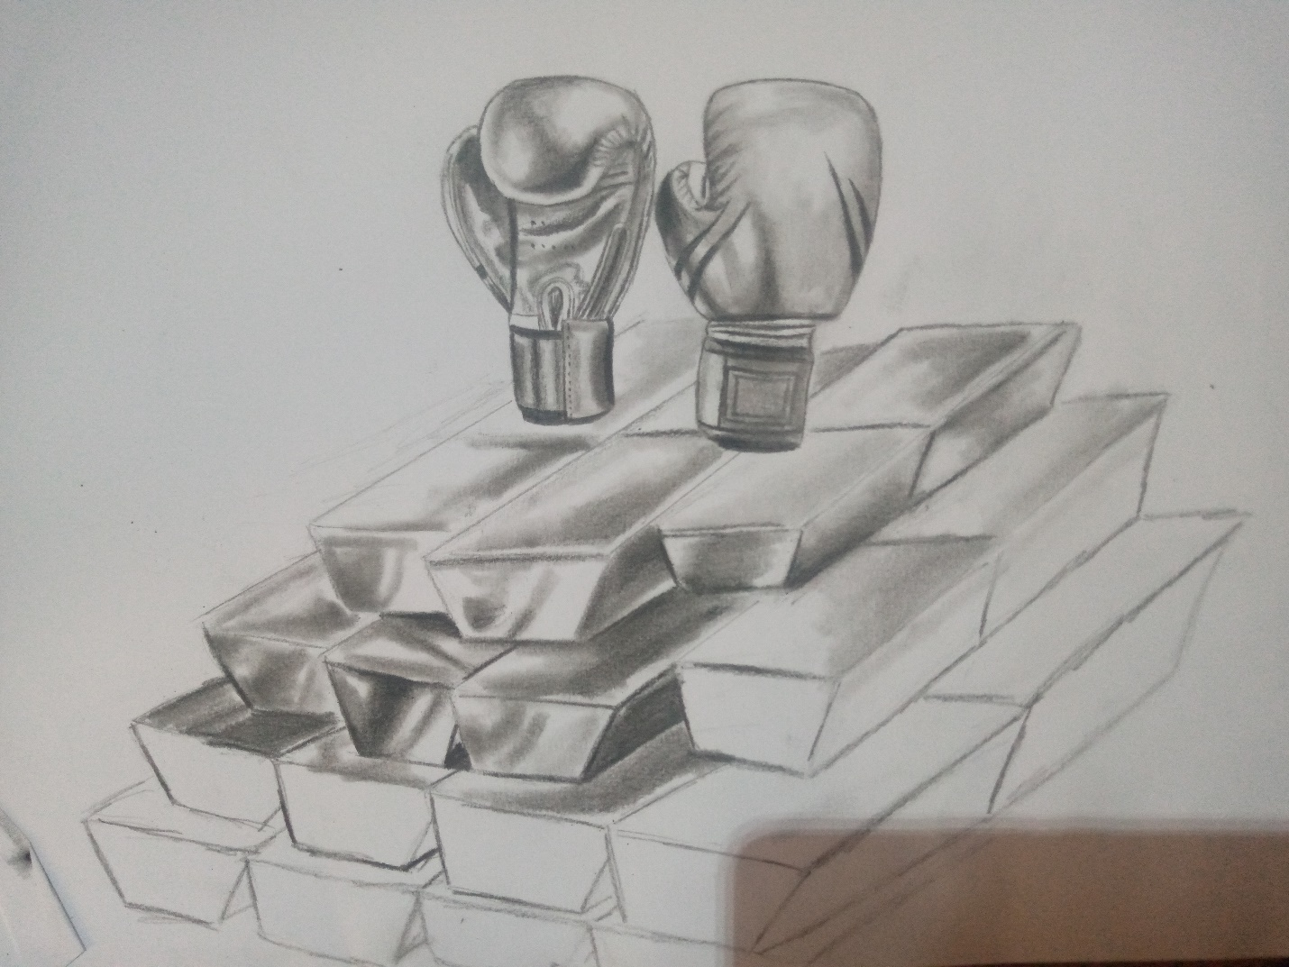

A sketch of boxing gloves on gold bars arranged as a pedal stool

